Medi-Cal K-12 Schools Communications Social Media
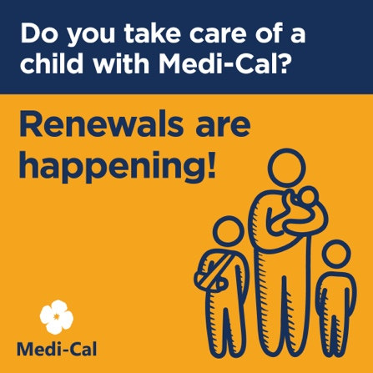
Alt Text: A family with an injured child with text “Do you care for a child with Medi-Cal? Renewals are happening.”
Social Post Copy:
Do you take care of a child with Medi-Cal? Renewals are happening! If you get a yellow renewal envelope, reply to stay covered. If a member is not automatically renewed, they will receive their envelope two months before their renewal date. Learn more at KeepMediCalCoverage.org.

